Rhetorical Analysis: New balance Visaro

Author’s Name
Institutional Affiliation
Course Name and Number
Instructor’s Name
Due Date

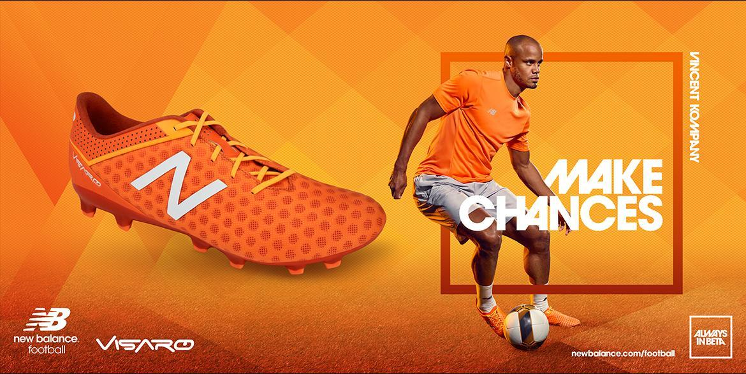
Rhetorical Analysis: New balance Visaro
Audience Analysis: This advert was placed on social media to help market new Visaro boots. Notably, Visaro boots ably, this advert display the new Visaro boots as the primary athletic footwear delivering a supportive and comfortable sporting experience to the buyers. The ad uses persuasive and informative messages urging consumers to get a pair of similar boots to be exceptional football players like Vincent whose image has been used to market the brand. Football footwear like the one in the ad is designed is for males playing soccer. Notably, the shoes are specifically for use in the pitch. Therefore, professional soccer male players are the primary targeted audience for this ad
There exists a wide range of male sports footwear in the industry today. The competition among companies that produce such products remains to be stiff. However, advertising plays a crucial role in marketing products. Besides, a good advert needs to be unique to catch the viewers' attention at emotional levels, enhancing reliability and authenticity. In the new balance Visaro ad, the image of a renowned professional soccer player has been utilized to create a strong brand connection with the viewers and consumers. Additionally, the advert uses short and precise messages to inform the target audience about the new product. Pathos, ethos, and Lagos are utilized in the ad to achieve its purpose. Consequently, elements of images, text, and rhetoric visuals have been used to persuade viewers to purchase the product. Therefore, ‘Make Chances’ is considered an effective technique applied in the ad to highlight the persuasive reasons to back up the claims for having to choose this brand.
All three rhetorical devices have been used in the advert. Ethos, for instance, has been utilized to build credibility. In the ad, the image of Vincent's Kompany creates an impression of trust and reliability between the company and the viewers. A textual presentation, “make chances" represents a written ethos that highlights the reliability of the new product. Additionally, it indicates that when one puts on the shoes, they can magically create chances that surpass the normal. Consequently, the incorporation of Vincent's image is a visual presentation of ethos. Celebrity endorsements are crucial in introducing new products to the market. Besides, the celebrity's image commands attention from both fans and club members. Therefore, featuring his image in the advertisements not only grabs the consumers' attention but also enhances the general visibility of the brand and product to the public domain.
This ad uses both visual and written techniques to demonstrate positive emotions. The key objective of incorporating ethos (emotions) is to encourage purchase among consumers. Company image, for instance, creates a fashionable presentation of the shoes. The visual representation of the company puts the brand on the right side of popular opinion. Essentially, consumers might purchase the new Visaro product to believe that it will transform them into phenomenal players like Vincent Kompany. Visual evidence of the shoes beside Kompanys image also depicts fashionable and cute sportswear for the men, thus enhancing their curiosity and feelings inviting them to purchase the shoes.
Positive affirmations through the words “make chances" invite positivity and encourage consumers to be actively associated with the new product. Besides, the words can also trigger internal excitement and curiosity, thus, causing consumers to try out the product. Consequently, the slogan also acts as a motivation that helps build inspired emotions towards the target audience. Hence, the fear of being left out is articulated hence attracting as many people as possible towards the product. Thus, the written evidence insets pressure on men playing soccer to buy the product as it is directly associated with success.
This advert has used logos to present logic and reason of the product to the audience. This is achieved through close views of the product. The rational appeal aims to persuade consumers into purchasing the product. For example, the presentation of a soccer icon creates a logical appeal that cannot be overlooked. Written evidence, “Make chances”, has been crafted logically to complement both the product and the advertisement. Additionally, it can also be regarded as a motivating and minimalistic slogan that ensures the credibility of the products. Visual logic is achieved through the image of Kompany. Using this technique indicates that the product is among the best men's footwear existing in the market today. Therefore, the image shows that top celebrities have accepted the brand; hence it is dominant in the universal football world.
In conclusion, the business world experiences constant changes. For this reason, companies are expected to up their game in marketing products and services. The ad has acknowledged the transition by introducing a new brand of male footwear in the market. Additionally, the organization has bought the change by creating ethos, pathos, and logos blend to convince buyers to purchase the products. Ethos, for instance has been used to portray the credibility of the product. Through the image of a renowned soccer player, the ad has developed different emotions in the heart of consumers hence persuading them to purchase the product. The textual presentation has been used to create logic for the audience by portraying a positive perspective of the company's goods to the targeted audience. Generally, the ad is appealing and depicts new modern trends hence attractive to a wide range of buyers.

